**Lab: S3 basic Operations**

1. Sign into the AWS Management Console and open the Amazon S3 console at<https://console.aws.amazon.com/s3>.
2. Click **Create Bucket**.

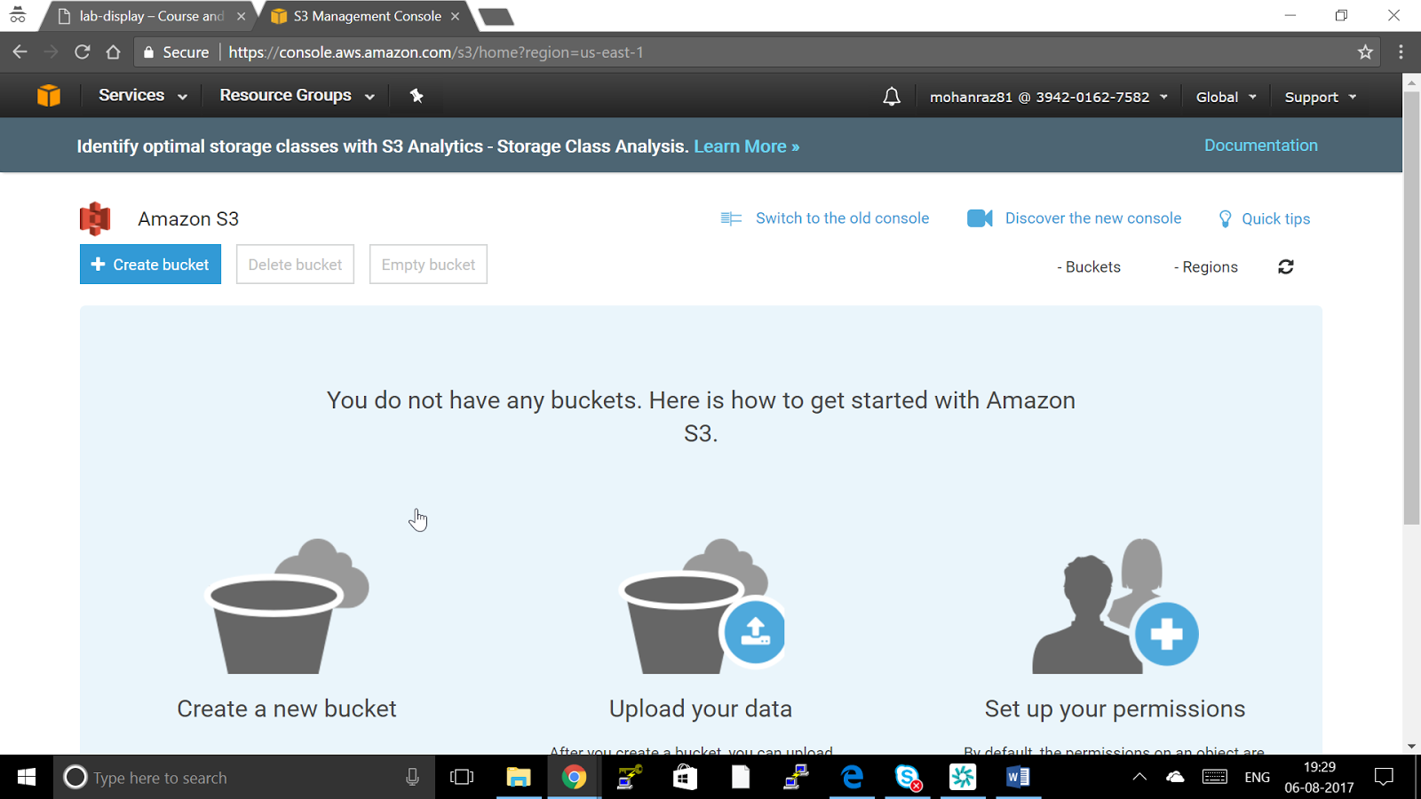

1. In the **Create a Bucket** dialog box, in the **Bucket Name** box, enter a bucket name.

The bucket name you choose must be unique across all existing bucket names in Amazon S3. One way to help ensure uniqueness is to prefix your bucket names with the name of your organization. Bucket names must comply with certain rules. For more information

Bucket name in Course and Labs should follow this guideline USERNAME-REGION NAME-UNIQUE NAME OF THE BUCKET for example mohanraz81-us-east-1-testbucket

* Bucket names must be at least 3 and no more than 63 characters long.
* Bucket names must be a series of one or more labels. Adjacent labels are separated by a single period (.). Bucket names can contain lowercase letters, numbers, and hyphens. Each label must start and end with a lowercase letter or a number.
* Bucket names must not be formatted as an IP address (e.g., 192.168.5.4).
* When using virtual hosted–style buckets with SSL, the SSL wild card certificate only matches buckets that do not contain periods. To work around this, use HTTP or write your own certificate verification logic.

**Note**

After you create a bucket, you cannot change its name. In addition, the bucket name is visible in the URL that points to the objects stored in the bucket. Ensure that the bucket name you choose is appropriate.

1. In the **Region** box, select a region. For this exercise, select **your Allocated Region** from the drop-down list.
2. Click **Next**.
3. Setting Bucket properties we will look in to next Lab So say Next
4. Setting permissions

You can provide permissions to Any IAM user Read/Write Access to Objects or Setting Permission to the objects

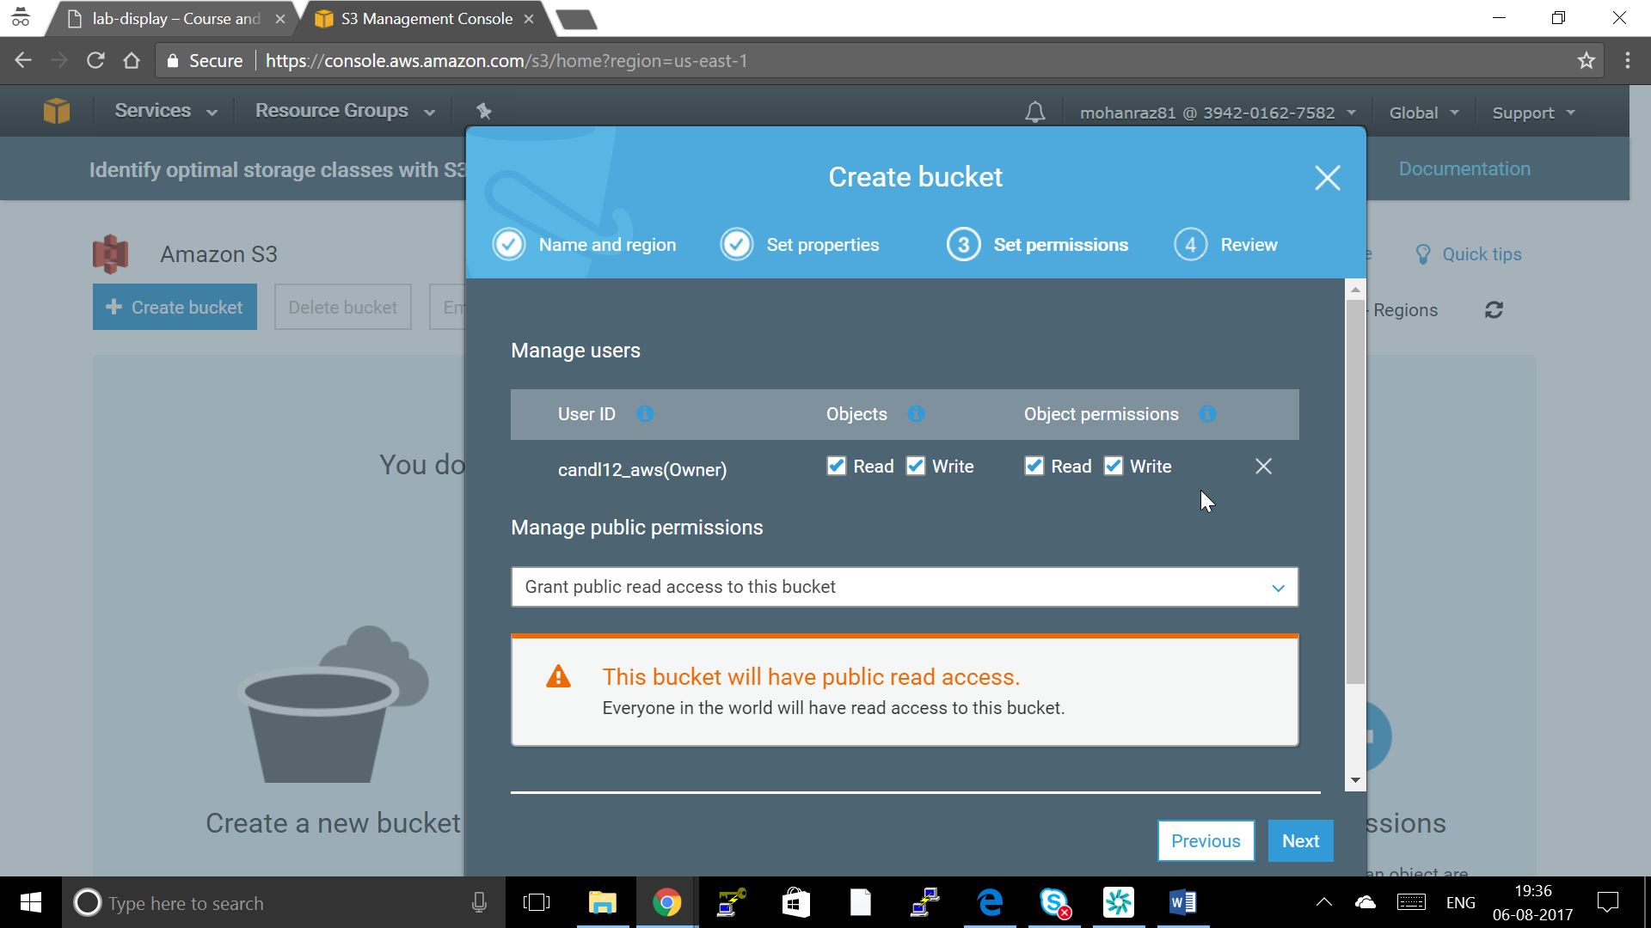

You can provide Grant Public Read access to the whole bucket

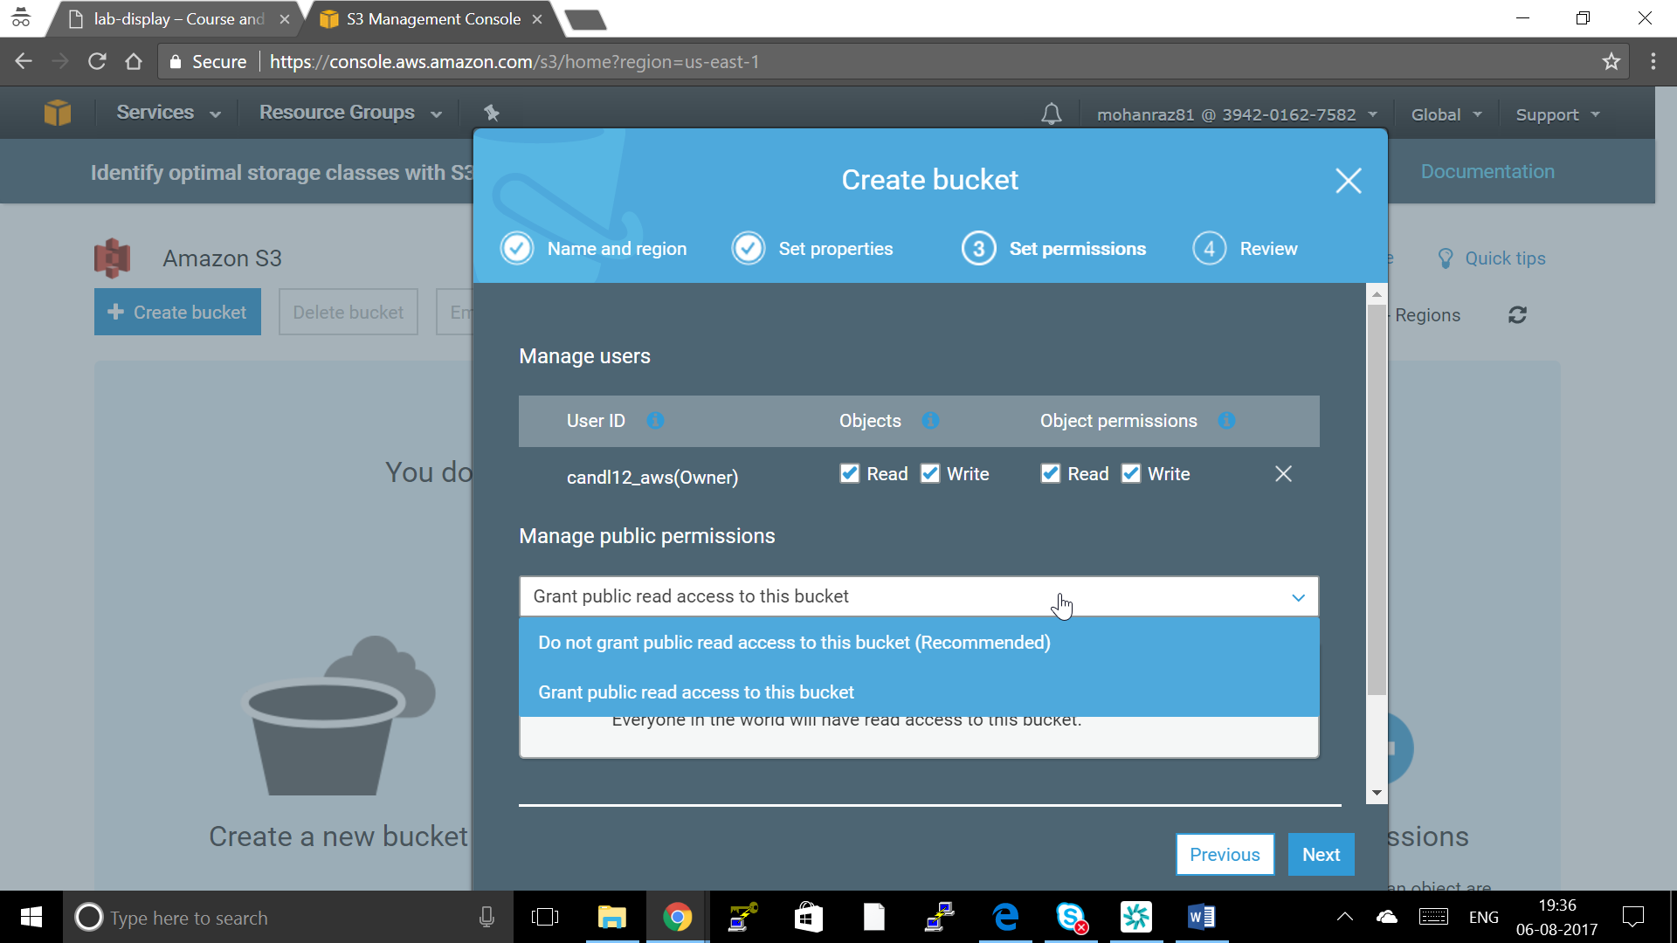

Setting Log Deliver group Write access we will see in Next Lab

Click Next

1. Review and Create Bucket

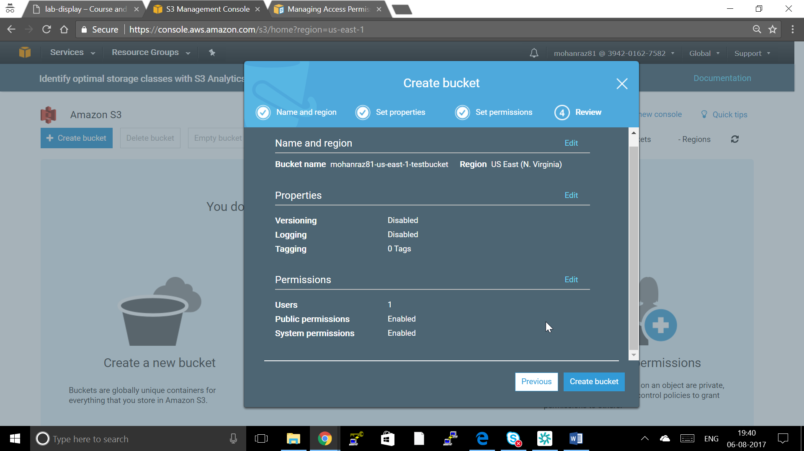

1. Once Created Click on the bucket

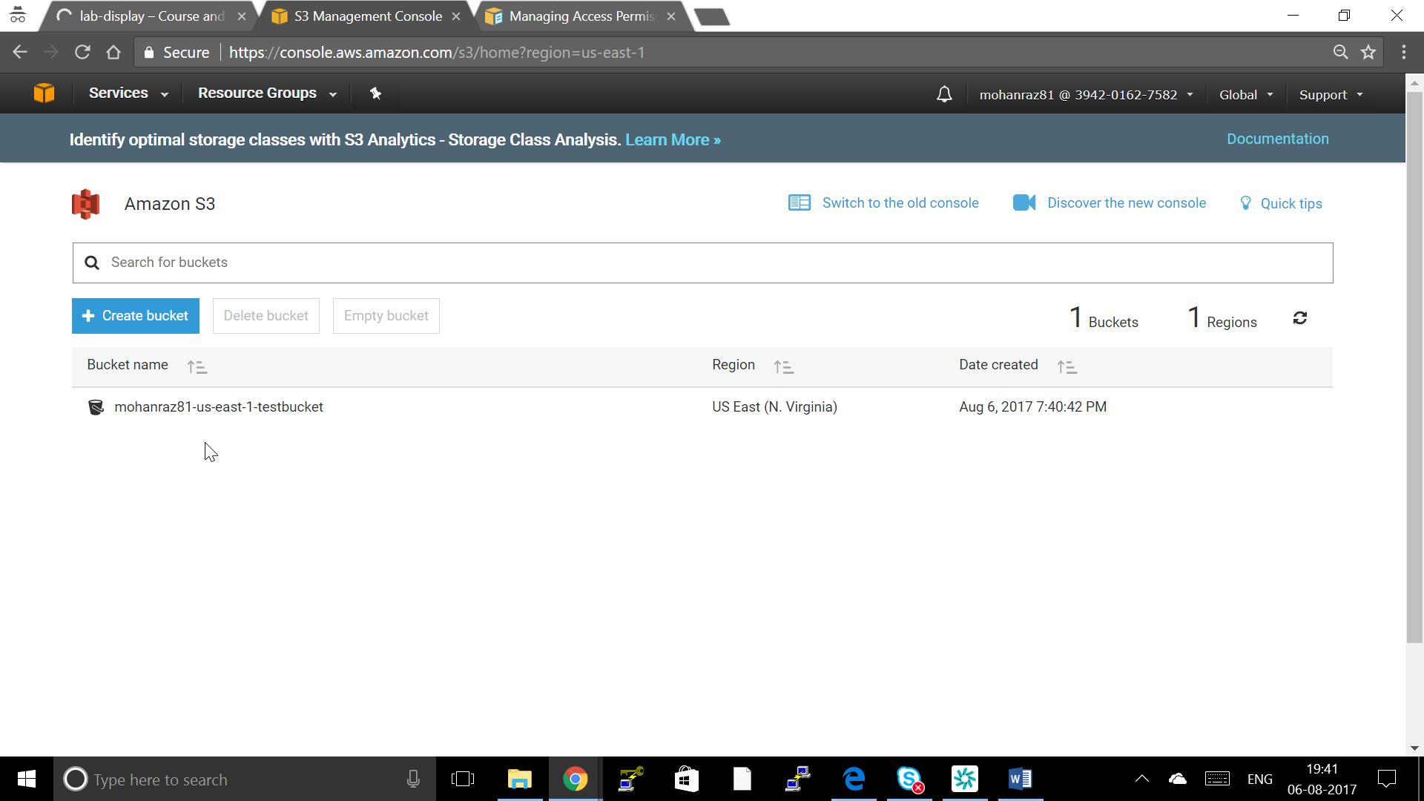

1. Upload a File by clicking a Upload

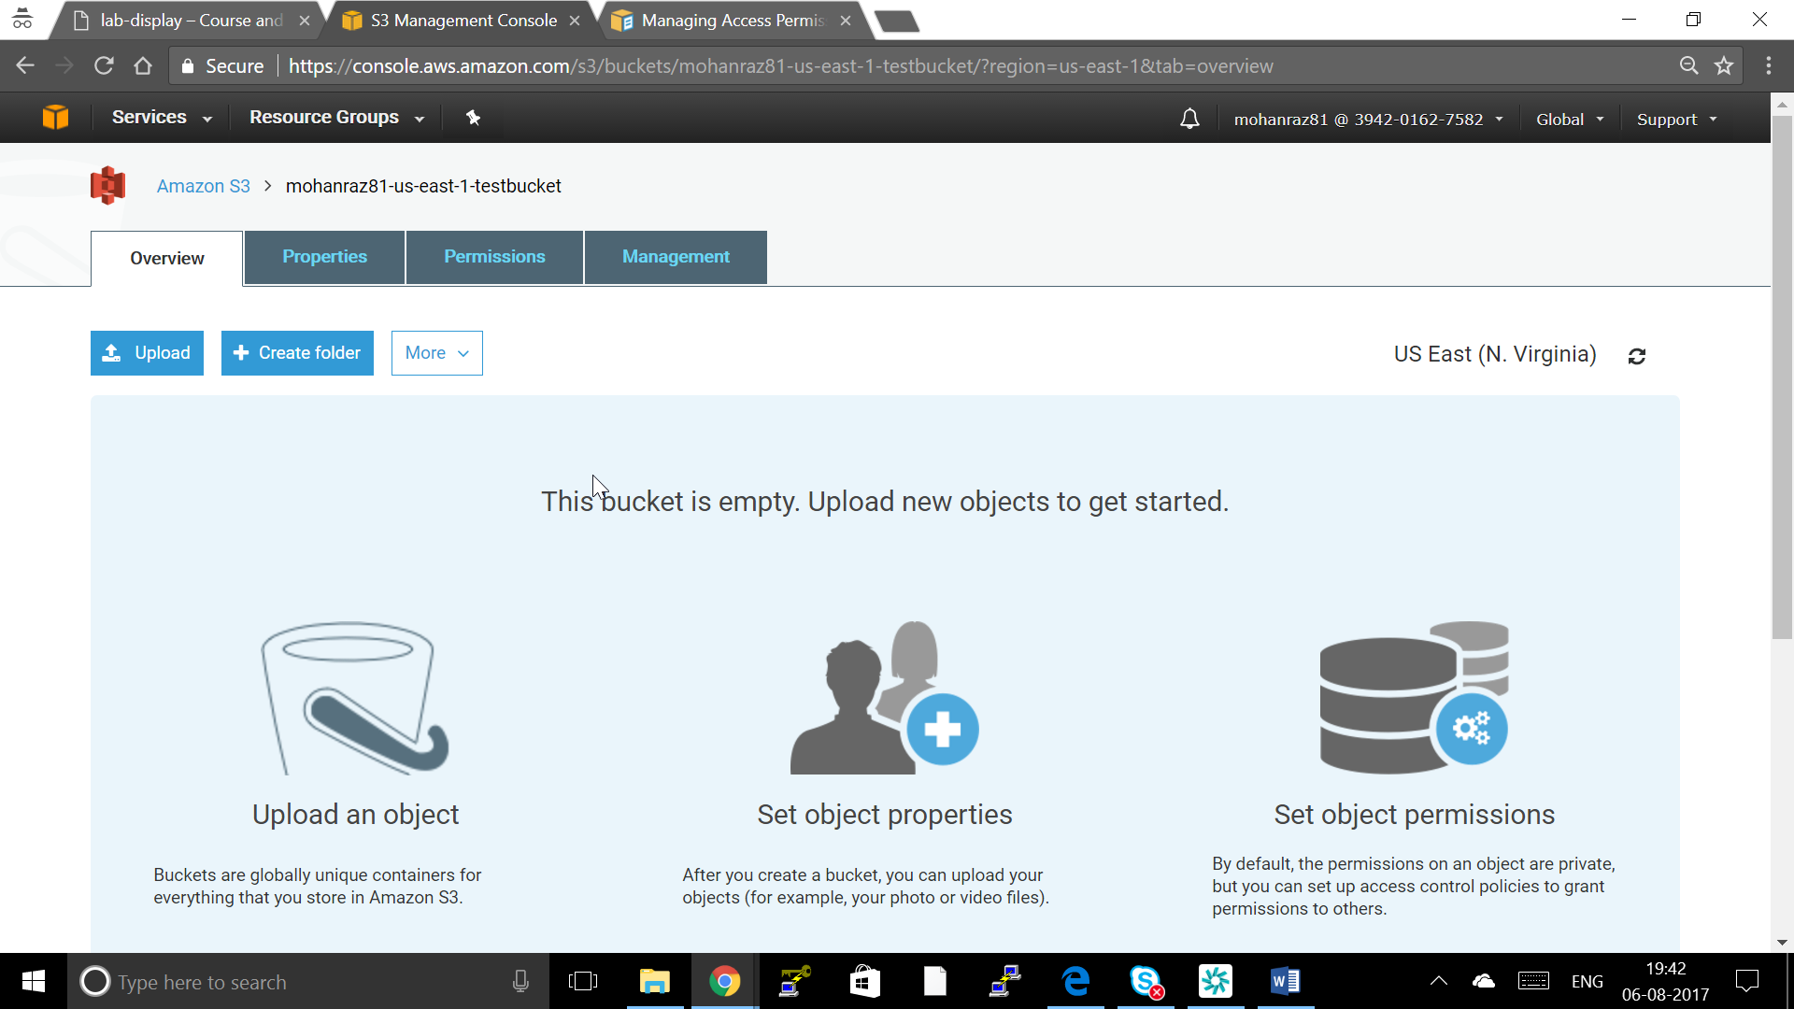

1. Click Add files and choose a file or multiple files from your machine and upload and click next

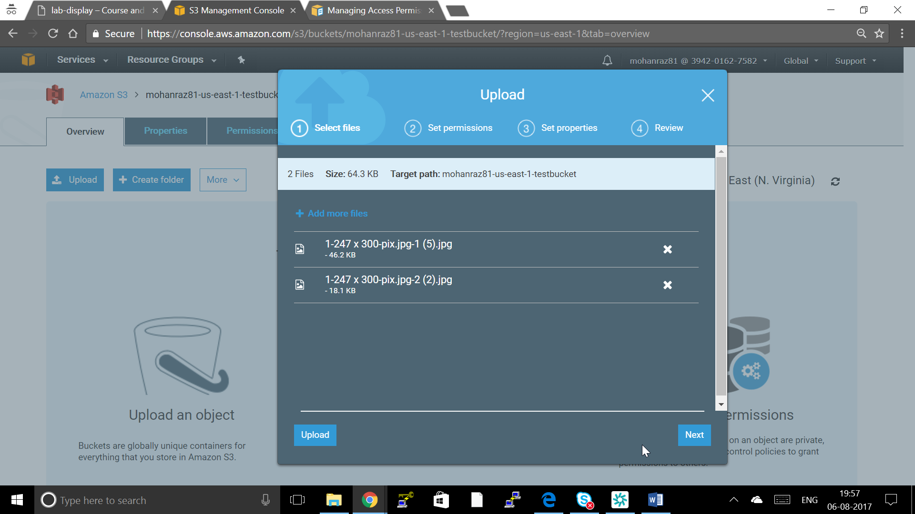

1. Give permissions for objects like adding a IAM user to provide Read Write or Object Permission access to this specific files

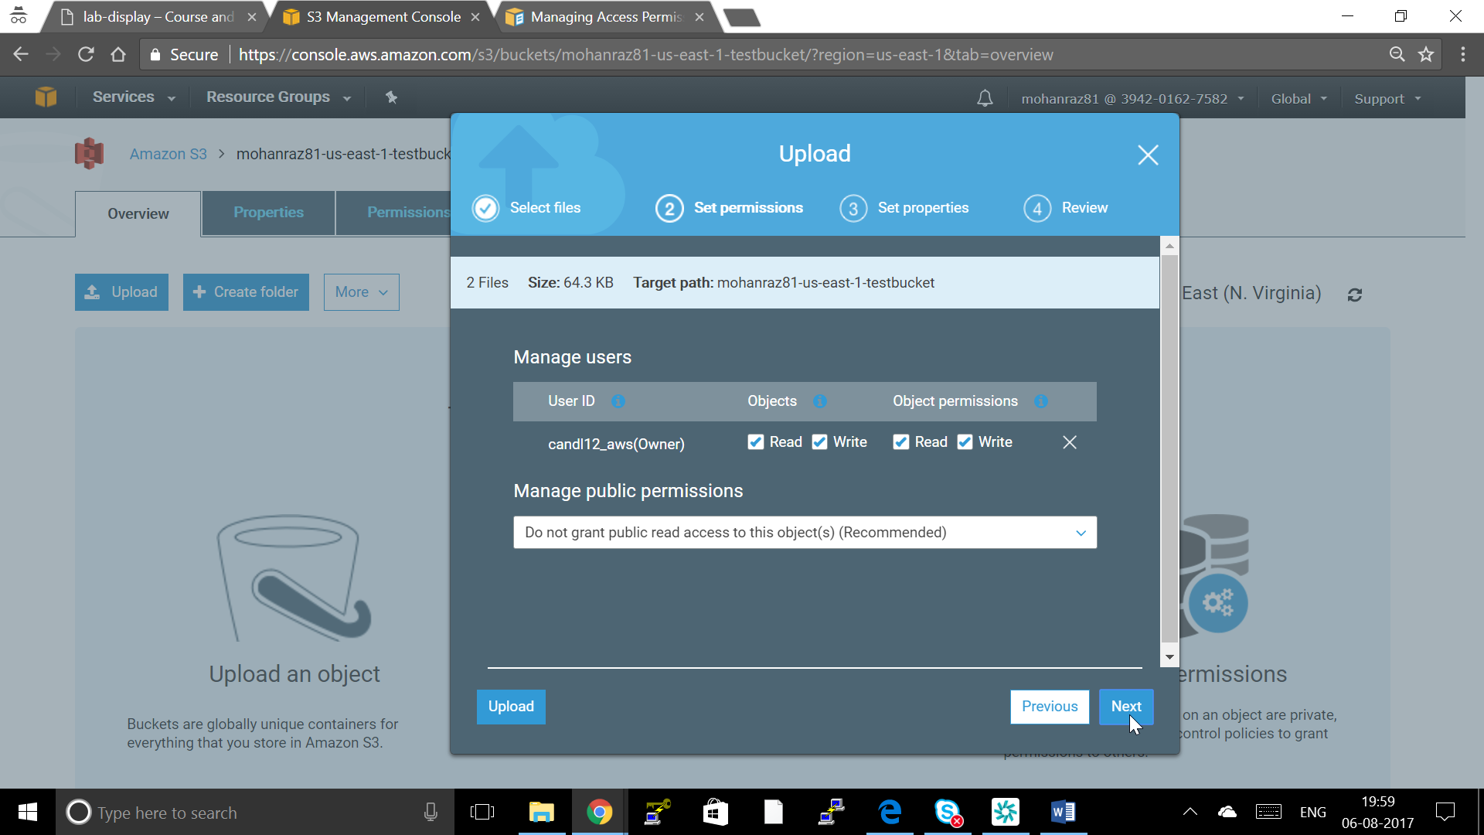

1. Set Properties you can choose which Storage class this object wanted to store to

Object can be stored as

* Standard S3
* Standard Infrequent Access
* Reduced Redudancy

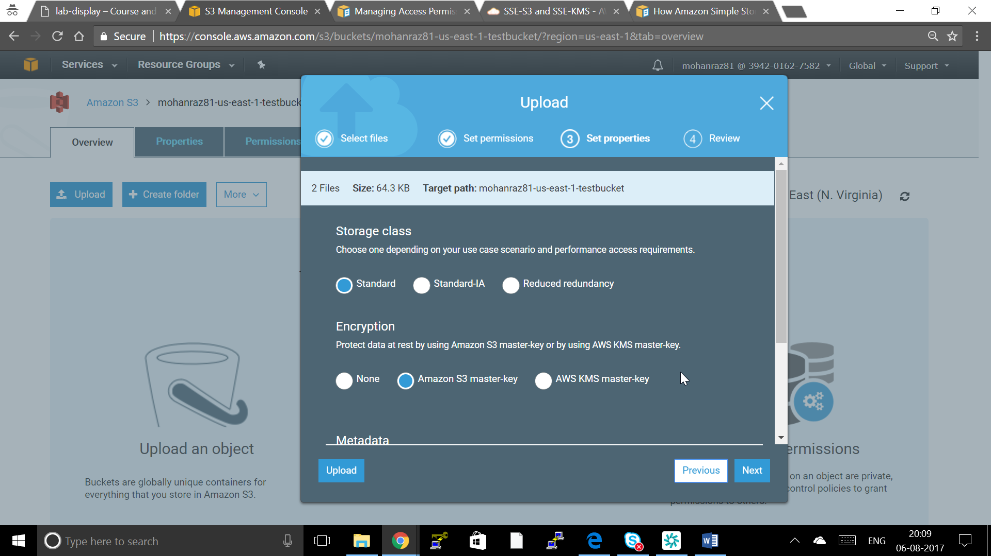

14. If you want to Encrypt the object by using the following Keys



Amazon S3 Master key

    Use the Amazon S3 service master key

        S3 will decrypt the object for anyone with permission to access this object.

  AWS Key Management services Key

Use an AWS Key Management Service master key

      S3 will decrypt the object for anyone with permission to access this object and permission to use the master key.

1. Metadata will Store Metadata about the object

Like

Content-type: jpg

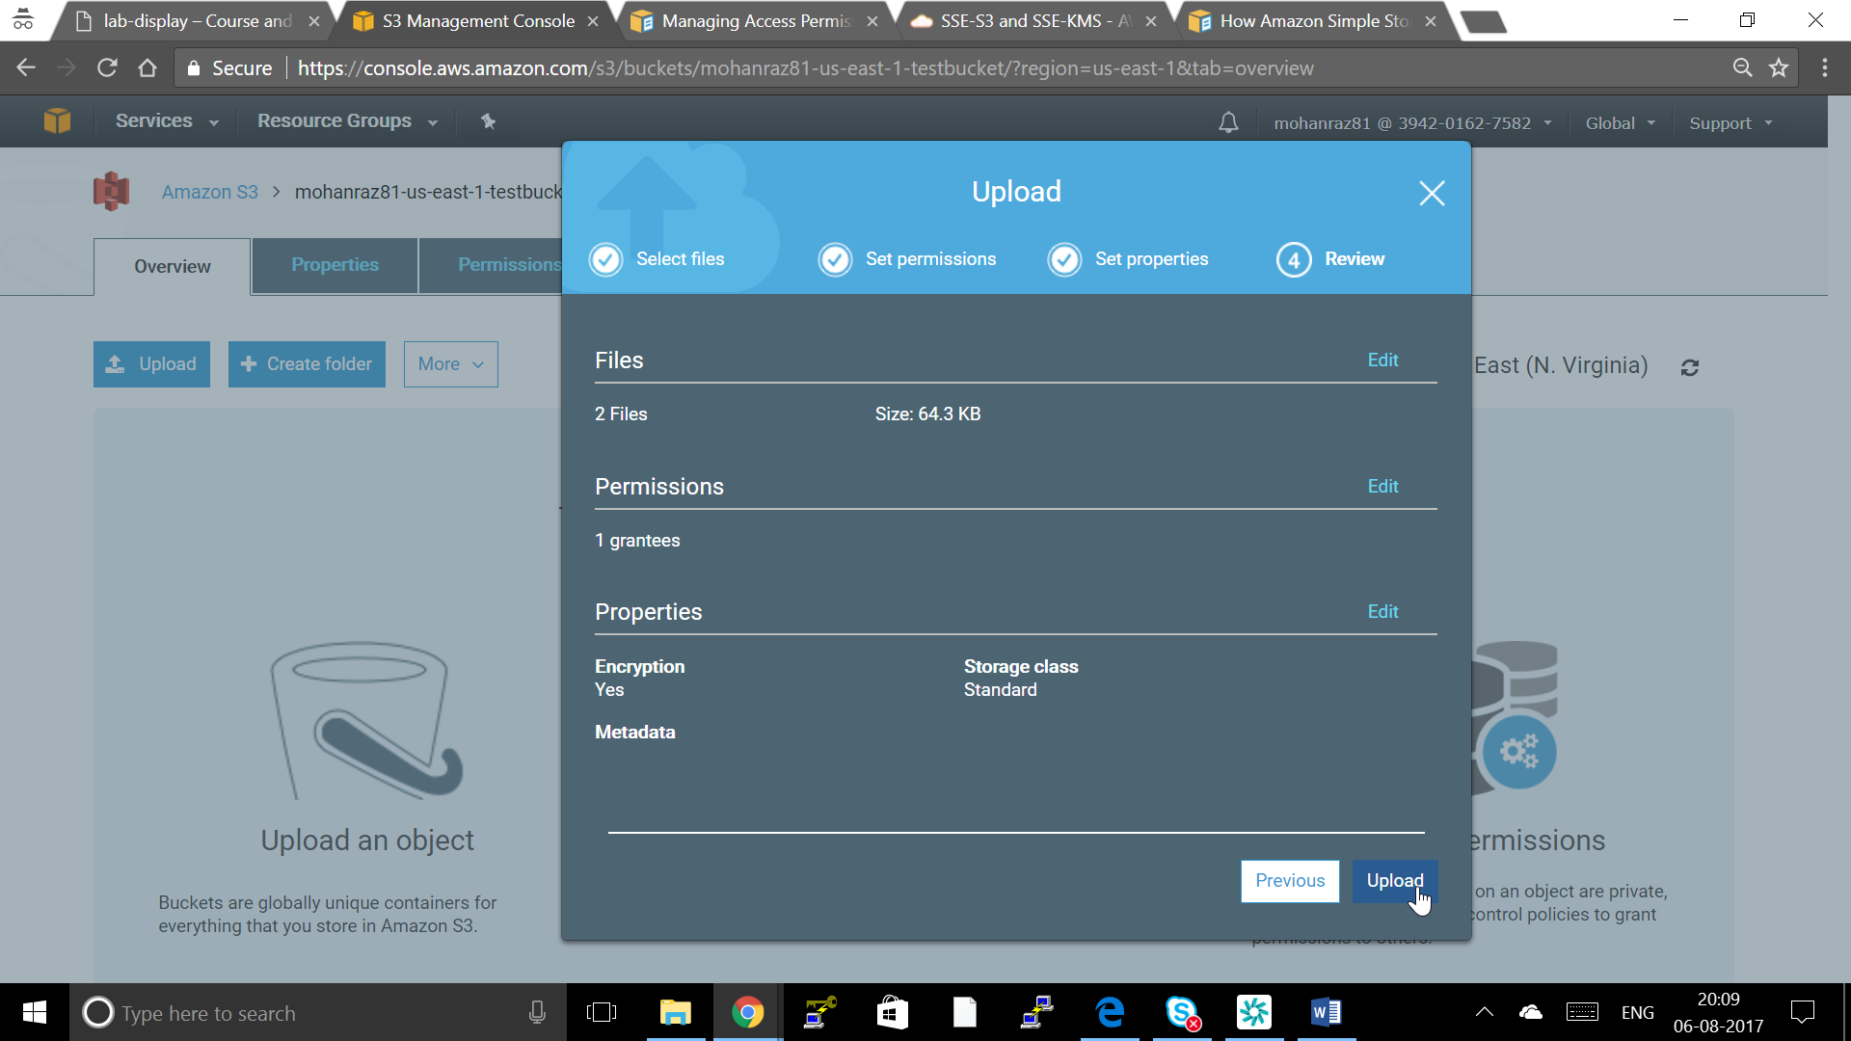

1. Click Next review and Upload



1. View an Object
   1. In the [Amazon S3 console](https://console.aws.amazon.com/s3), in the **Objects and Folders** list, right-click the object or objects that you want to open or download, then click **Open** or **Download** as appropriate.

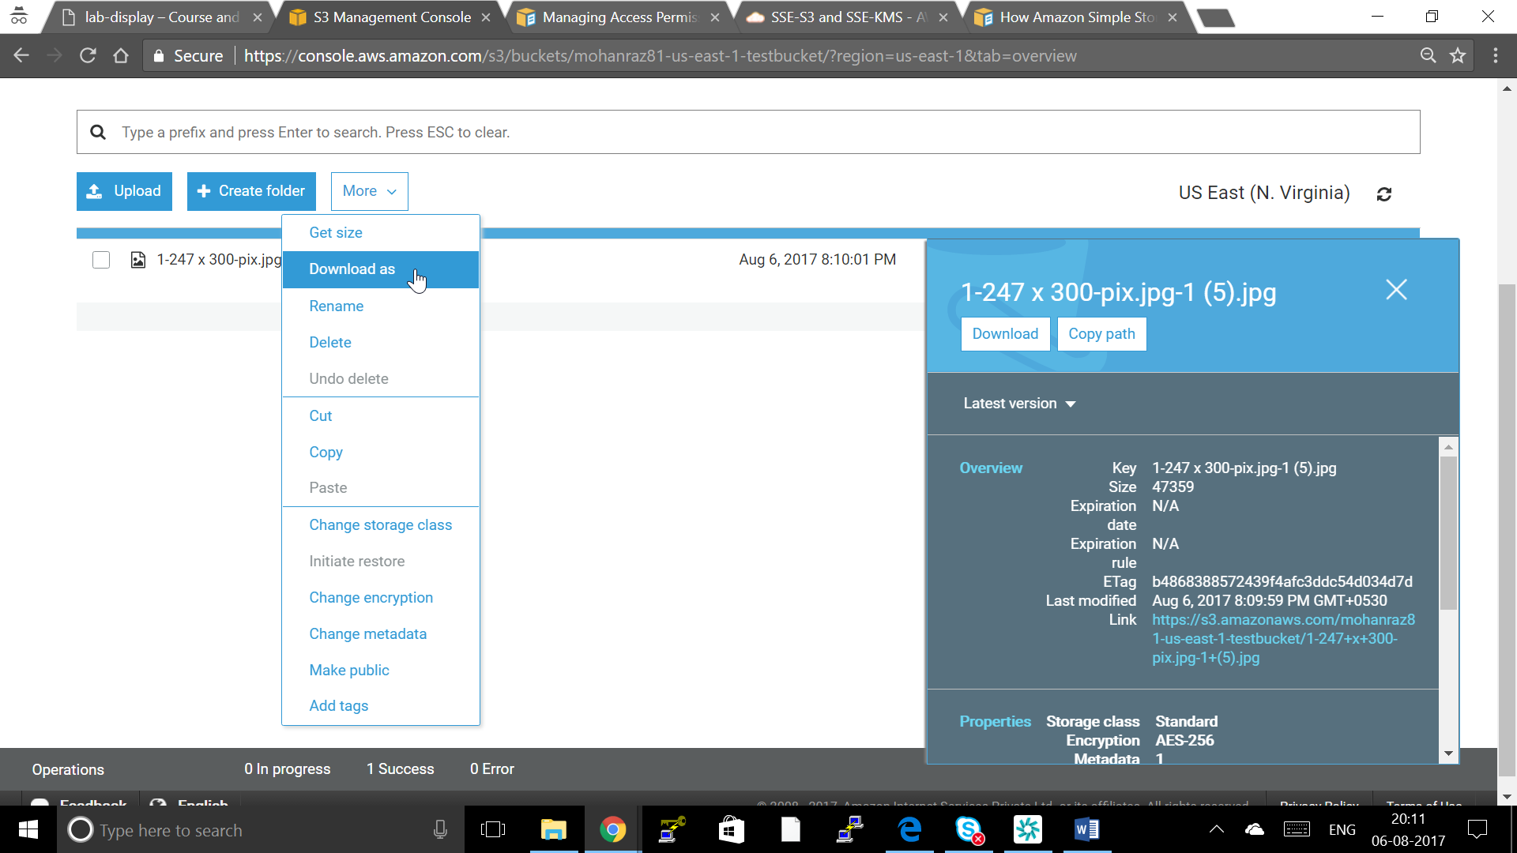

* 1. If you are downloading the object, specify where you want to save it. The procedure for saving the object depends on the browser and operating system that you are using.
  2. By default, your Amazon S3 buckets and objects are private. To make an object viewable by using a URL, for example, https://s3.amazonaws.com/Bucket/Object, you must make the object publicly readable.

1. **To move an object**
   1. In the [Amazon S3 console](https://console.aws.amazon.com/s3), right-click the object that you want to move, and then click **Cut**.

You can use the **SHIFT** and **CTRL** keys to select multiple objects and perform the same action on them simultaneously.

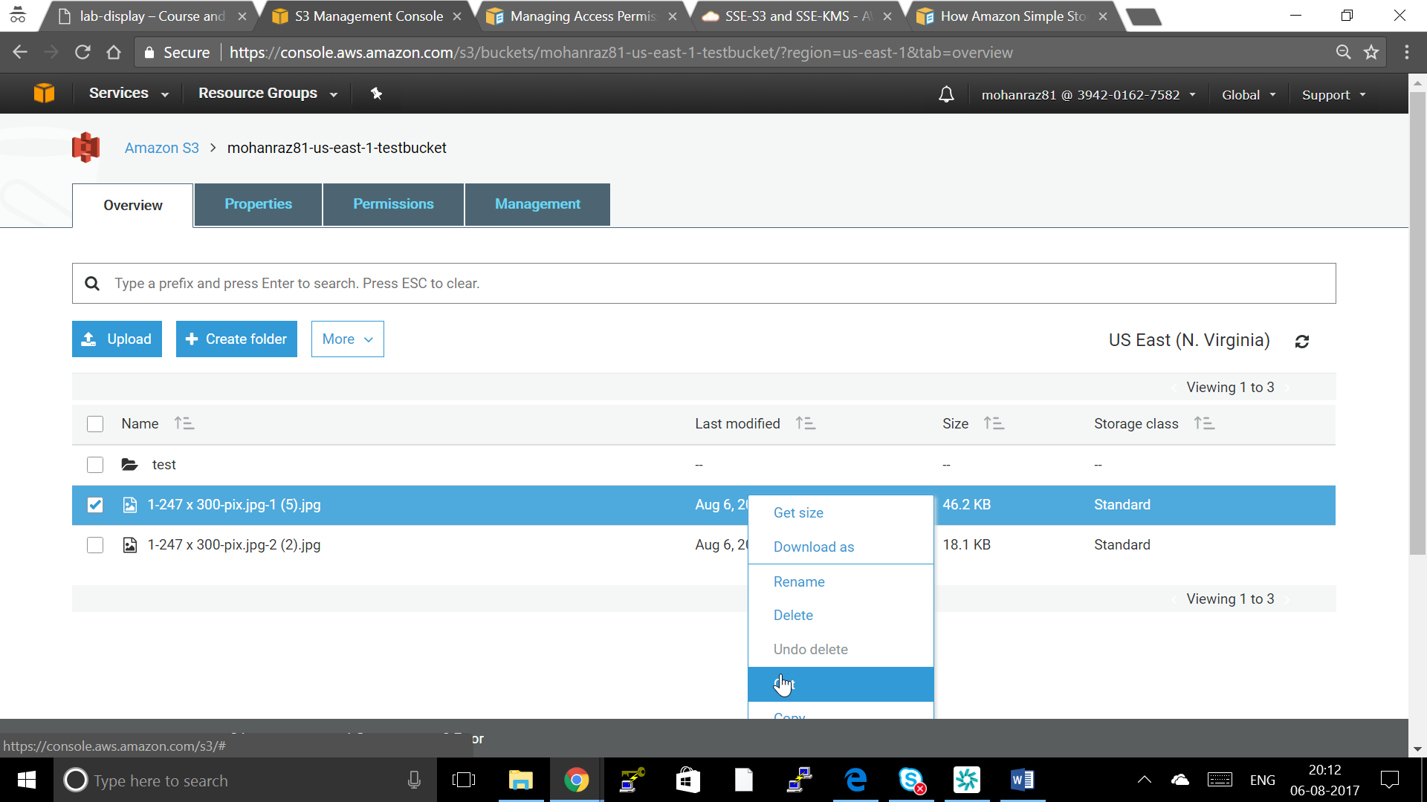

* 1. Navigate to the bucket or folder where you want to move the object. Right-click the folder or bucket and then click **Paste**.

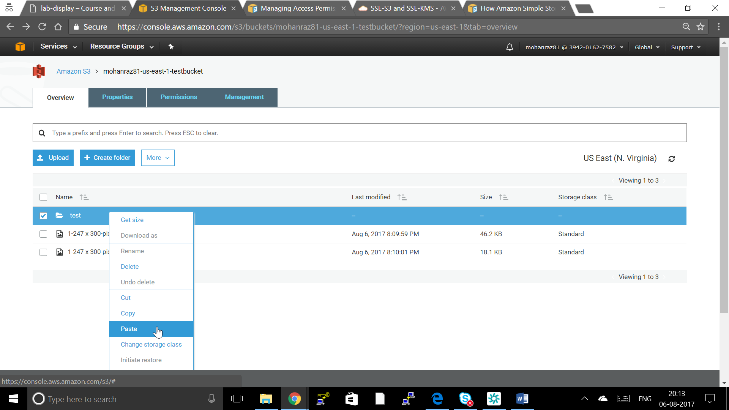

1. Delete the Objects
2. In the **Objects and Folders** panel, right-click the object that you want to delete, and then click **Delete**.

You can use the **SHIFT** and **CRTL** keys to select multiple objects and perform the same action on them simultaneous



When a confirmation message appears, click **OK**.

1. **To empty a bucket**

Click the bucket that you want to empty, and then click **Empty Bucket**.

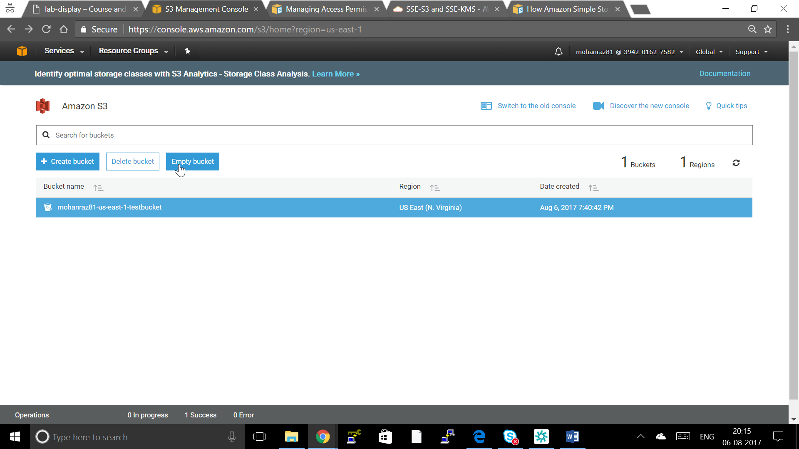

1. When a confirmation message appears, enter the bucket name and then click **Empty bucket**.



You can delete a bucket and all the objects contained in the bucket. For information on the limitations for deleting a bucket,

**Note**

When you delete a bucket, there may be a delay of up to one hour before the bucket name is available for reuse in a new region or by a new bucket owner. If you re-create the bucket in the same region or with the same bucket owner, there is no delay.

1. **To delete a bucket**
2. Choose the bucket that you want to delete, and then click **Delete Bucket**.

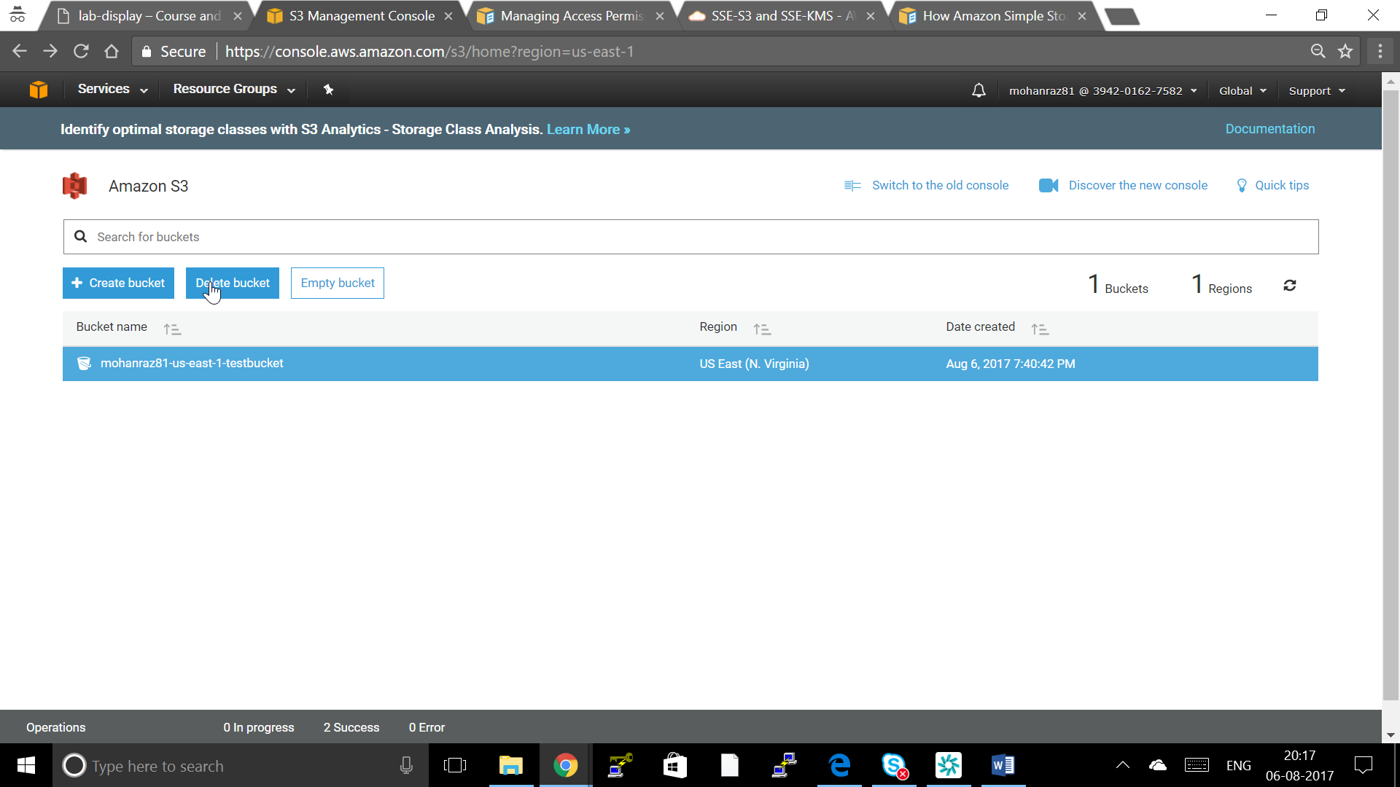

1. When a confirmation message appears, enter the bucket name and click Confirm.

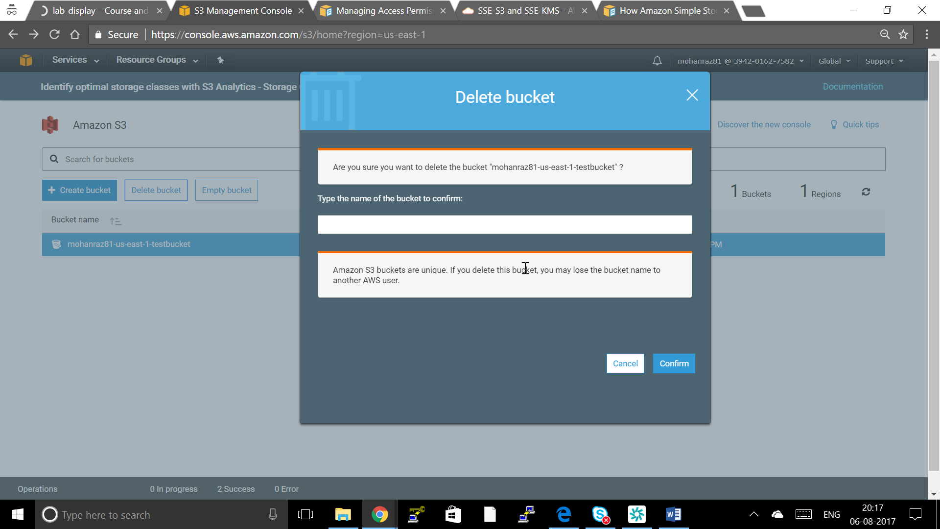

**Basic S3 Opeations using CLI**

1. Configure AWS CLI

**$ aws configure**

2. Create a Bucket

**$aws s3 mb s3://<bucket name >**

**$aws s3 mb s3://mohanraz81-us-east-1-testcli**

Or

**aws s3api create-bucket --bucket my-bucket --region us-east-1**

3. Make it public Readable

$ aws s3api create-bucket --bucket my-bucket --region us-east-1 –acl public-read

Full S3 CLI Reference

<http://docs.aws.amazon.com/cli/latest/reference/s3api/>